September
2021
Did you know that 1 in 13 children have a food allergy??
Help us keep your child safe!  Notify the CNP Director of any food allergies or intolerances by emailing a doctor’s note to bnash@csalabama.org.  Per the USDA and State Dept, an updated doctor’s note is required each year for us to provide meal substitutes.  We are happy to provide a healthy substitute! | 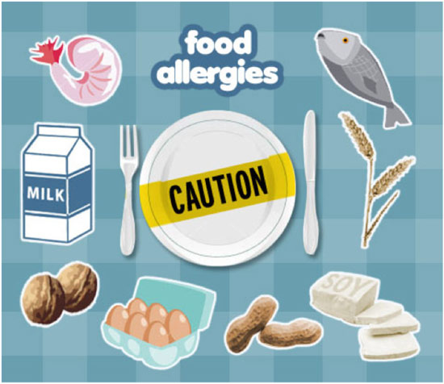  This Photo by Unknown Author is licensed under CC BY-SA-NC
Monday | Tuesday | Wednesday | Thursday | Friday
 |  | 1 | 2 | 3
 |  | Beef & Bean Burrito,  Refried Beans & Peaches | Chicken Wings  Cabbage & Dinner Roll  (ELEM: Chicken nuggets) | Uncrustables, Veggie Dippers, Watermelon  Brownie, Juice
6 | 7 | 8 | 9 | 10
Labor Day  No School | Hamburgers  Sweet Potato Fries & Juice | Ham & Cheese Croissant  Applesauce  Baby Carrots & Ranch and Chocolate Chip Cookie | Spaghetti with Meatballs  Green Beans and peaches | Hotdogs, French Fries  & Baked Beans
13 | 14 | 15 | 16 | 17
Chicken Tenders, Green Beans, Baby Carrots, Peaches & Dinner Roll | Salisbury Steak, Gravy, Mashed Potatoes Cinnamon Apples & Dinner Roll | Poppyseed Chicken Casserole, Broccoli, Peas & Carrots and Grapes | Beef & Bean Burrito, Mexican Corn and Mandarin Oranges | Pepperoni Pizza, Sweet Potato Fries and watermelon
20 | 21 | 22 | 23 | 24
Corn dogs, French Fries  & Baked Beans | Chicken Soft Taco  Pinto Beans, Corn &  Juice | Spaghetti, Green Beans  Chocolate Chip Cookie | Ham & Cheese Croissant  Baked Chips  Baby Carrots & Ranch | Pepperoni Pizza  Corn, Salad & Juice
27 | 28 | 29 | 30
Chicken & Cheese Quesadilla, Refried beans | BBQ Sandwich, Cole Slaw,  Baked Beans | Chicken salad sandwich, Chips, Grapes, Baby Carrots with ranch | Chicken Alfredo  Broccoli | Pepperoni Pizza Lunchables, Green Beans
**Fruit & choice of milk will be offered at every meal**

