November
2021
Lunch Menu
Happy  Thanksgiving ! | 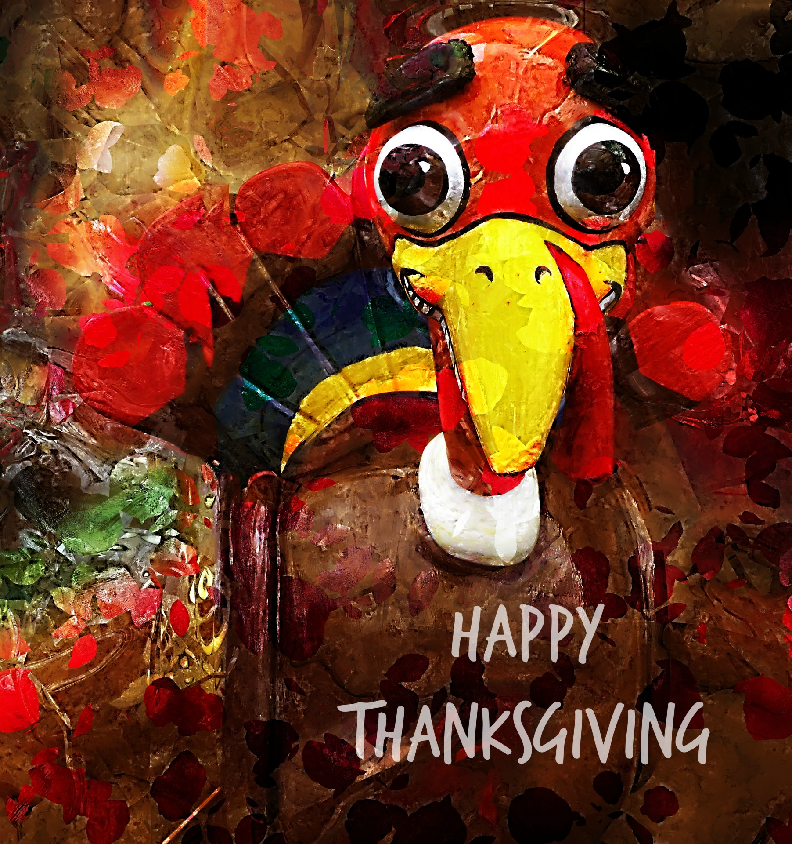
Sunday | Monday | Tuesday | Wednesday | Thursday | Friday | Saturday
 | 1 | 2 | 3 | 4 | 5 | 6
 | Pepperoni  Calzone  Corn on cob  Glazed carrots  Peaches | Chicken tenders  French Fries  Mixed Veggies  Pineapples | Salisbury Steak  Mashed Potatoes  Green beans  Pears | Ham and Cheese  Sandwich  Chips  Veggie dippers  juice | BBQ Pork Sandwich  Baked beans  Coleslaw  Apple slices
7 | 8 | 9 | 10 | 11 | 12 | 13
 | Chicken, brocoli & Rice casserole  Mandarin oranges | Hotdog  Potato Wedges  Carrots &Peas  Peaches | Chili  Cheese toast  Cocktail fruit | Veteran’s Day | Chicken Quesadilla  Spanish rice  Mexican corn  juice
14 | 15 | 16 | 17 | 18 | 19 | 20
 | Corndog  Sweet potato fries  Corn on cob  Grapes | Taco Soup  Tortilla Chips  Oranges | Turkey, Pepperoni cheese sandwich  Chips  Steamed broccoli | Baked Ham or Turkey with gravy  Yams  Collard greens  dressing | Mexican Pizza  French Fries  Side salad  juice
21 | 22 | 23 | 24 | 25 | 26 | 27
 |  |  |  | Thanksgiving Holidays! Have a safe and wonderful week!
28 | 29 | 30
 | Cheeseburgers  Potato Wedges  Green beans  juice | Chicken Nuggets  Mac and Cheese  Carrots  Fruit cup

