August
2021
Welcome back, families! We are so excited to have you! We are wrapping you in prayer for a healthy and productive new school year!
Child Nutrition News  - Please, submit your child’s lunch form! You may do so at www.lunchapp.com . While all children will eat free this school year, an application is what determines your child’s eligibility for P-EBT cards. **An application is not needed if you participate in SNAP or TANF.  - If your child has an allergy or food intolerance, please send a copy of your doctor’s note to bnash@csalabama.org. | 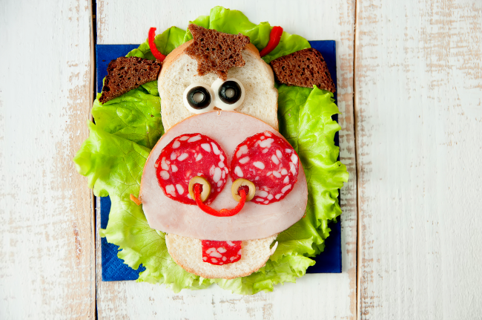
Monday | Tuesday | Wednesday | Thursday | Friday
 |  |  | 29 | 30
 |  |  | Hotdogs  French Fries  Green Beans | Rectangle Pizza  Corn  Apple Juice
2 | 3 | 4 | 5 | 6
Chicken Fingers  Green Beans  Dinner roll | Chicken soft taco  Pinto Beans  Juice | Spaghetti  Cesar Salad  Chocolate Chip Cookie | Ham & Cheese Croissant  Baked Chips  Baby Carrots & Ranch | Pizza  Corn, salad  Juice
9 | 10 | 11 | 12 | 13
Chicken & Cheese Quesadilla  Pinto Beans | Salisbury Steak  Mashed Potatoes  Candied Yams, Juice | Burgers  Sweet Potato Fries, salad  Animal crackers | Turkey & Cheese Sandwich, Baked Chips  Juice | Chicken Wings  Cabbage, Baby Carrots & Ranch
16 | 17 | 18 | 19 | 20
Breaded Catfish  Hushpuppies  Cabbage | Chicken Alfredo  Broccoli  Juice | Beef & cheese nachos  Pinto beans | Pancakes  Sausage  Grits | Pizza  Corn  Juice
22 | 23 | 24 | 25 | 26
Chicken & Rice Casserole  Green Peas | Corndogs  Fries  Green Beans | Chicken Sandwich  Fries, juice | Chicken Parmesan  Cesar Salad  Italian Bread | Uncrustables, carrots  Baked Chips  Brownie, Juice
29 | 31
Sliced ham, Dinner roll, Sweet potato casserole | Fish sticks  Hushpuppies  Mixed vegetables
**Fruit & choice of milk will be offered at every meal**

